CREATE TABLE IF NOT EXISTS Employee

(

ENO BIGINT,

FNAME VARCHAR(50) NOT NULL,

LNAME VARCHAR(50) NOT NULL,

DESIG VARCHAR(50),

MGR BIGINT,

DOB DATE,

HDATE DATE,

Salary NUMERIC(8, 2),

Commission NUMERIC(8, 2),

CONSTRAINT pkey PRIMARY KEY (ENO),

CONSTRAINT foreign_key FOREIGN KEY (MGR) REFERENCES Employee (ENO),

CONSTRAINT DOB_Check CHECK ( YEAR(DOB) <= 1980 ),

CONSTRAINT Salary_Check CHECK ( Salary BETWEEN 20000 AND 100000 )

);

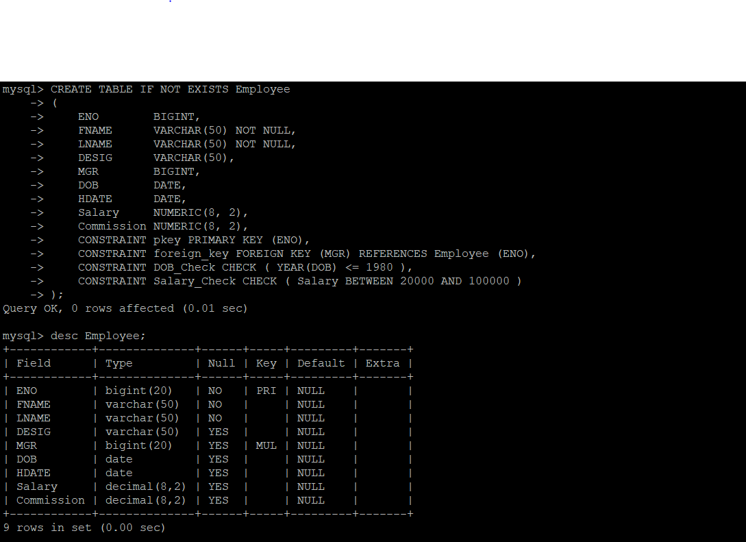

INSERT INTO Employee

VALUES (101, 'Janson', 'Hass', 'President', NULL, STR_TO_DATE('12/09/1973', '%d/%m/%Y'),

STR_TO_DATE('12/01/2003', '%d/%m/%Y'), 87500.00, NULL),

(110, 'James', 'Thompson', 'Manager', 101, STR_TO_DATE('06/01/1973', '%d/%m/%Y'),

STR_TO_DATE('25/02/2008', '%d/%m/%Y'), 52950.00, NULL),

(115, 'Celia', 'Geyer', 'Manager', 101, STR_TO_DATE('07/09/1972', '%d/%m/%Y'),

STR_TO_DATE('17/09/2007', '%d/%m/%Y'), 46850.00, 22530.00),

(117, 'Robert', 'Stern', 'Manager', 101, STR_TO_DATE('04/02/1972', '%d/%m/%Y'),

STR_TO_DATE('15/03/2006', '%d/%m/%Y'), 49900.00, 20555.00),

(135, 'Linda', 'Pulaski', 'Salesman', 110, STR_TO_DATE('29/08/1968', '%d/%m/%Y'),

STR_TO_DATE('19/09/2007', '%d/%m/%Y'), 21250.00, 14500.00),

(142, 'David', 'Henderson', 'Salesman', 110, STR_TO_DATE('02/02/1970', '%d/%m/%Y'),

STR_TO_DATE('23/03/2006', '%d/%m/%Y'), 21700.00, 12400.00),

(167, 'Martin', 'Spenser', 'Salesman', 110, STR_TO_DATE('09/02/1971', '%d/%m/%Y'),

STR_TO_DATE('28/07/2005', '%d/%m/%Y'), 27000.00, 16600.00),

(172, 'Smith', 'Nicholls', 'Clerk', 110, STR_TO_DATE('12/03/1965', '%d/%m/%Y'),

STR_TO_DATE('26/04/2003', '%d/%m/%Y'), 21850.00, NULL),

(154, 'Larry', 'Adamson', 'Salesman', 110, STR_TO_DATE('02/02/1974', '%d/%m/%Y'),

STR_TO_DATE('18/02/2004', '%d/%m/%Y'), 22250.00, 17000.00),

(179, 'Mathews', 'Pinka', 'Analyst Manager', 117, STR_TO_DATE('08/01/1975', '%d/%m/%Y'),

STR_TO_DATE('23/04/2008', '%d/%m/%Y'), 35000.00, NULL),

(183, 'Sally', 'Brown', 'Clerk', 179, STR_TO_DATE('29/08/1968', '%d/%m/%Y'),

STR_TO_DATE('14/07/2008', '%d/%m/%Y'), 21250.00, NULL),

(190, 'Christine', 'Jones', 'Analyst Manager', 117, STR_TO_DATE('13/09/1968', '%d/%m/%Y'),

STR_TO_DATE('05/09/2005', '%d/%m/%Y'), 34000.00, NULL),

(199, 'Michael', 'Parker', 'Clerk', 190, STR_TO_DATE('07/02/1971', '%d/%m/%Y'),

STR_TO_DATE('17/03/2004', '%d/%m/%Y'), 21600.00, NULL),

(200, 'John', 'Mehta', 'Clerk', 115, STR_TO_DATE('02/03/1975', '%d/%m/%Y'),

STR_TO_DATE('12/02/2006', '%d/%m/%Y'), 21350.00, NULL),

(137, 'Bruce', 'Wong', 'Salesman', 110, STR_TO_DATE('12/12/1976', '%d/%m/%Y'),

STR_TO_DATE('18/10/2005', '%d/%m/%Y'), 22250.00, 13000.00);

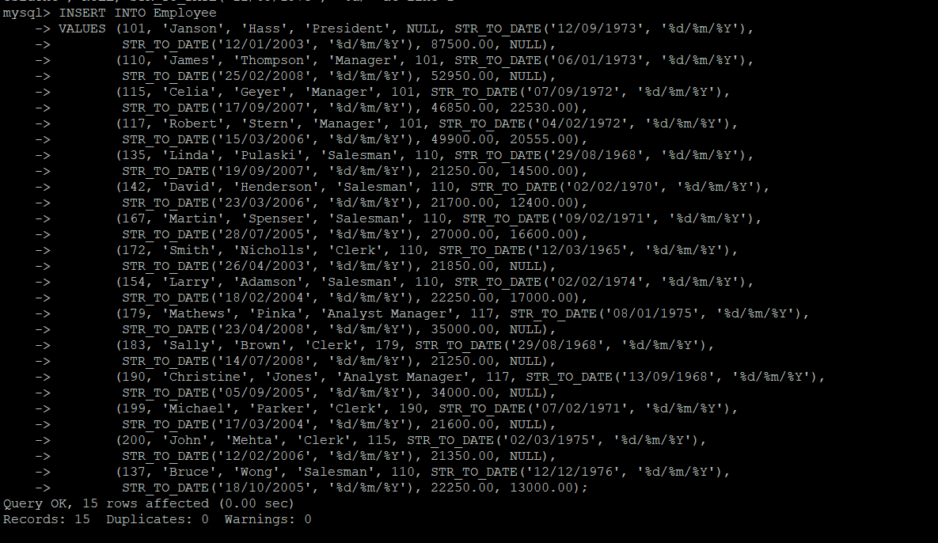

1)SELECT *

FROM Employee

WHERE DOB <= ANY (SELECT DOB FROM Employee WHERE ENO = 167);

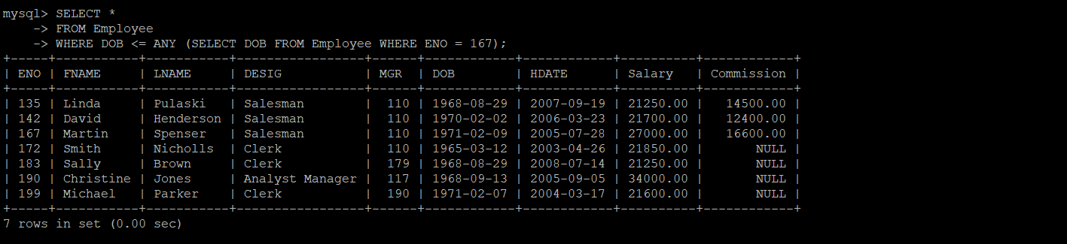

2)SELECT FNAME, LNAME

FROM Employee

WHERE TIMESTAMPDIFF(YEAR, DOB, CURRENT_TIMESTAMP) < 30;



3)SELECT *

FROM Employee

WHERE LNAME LIKE '%er%';

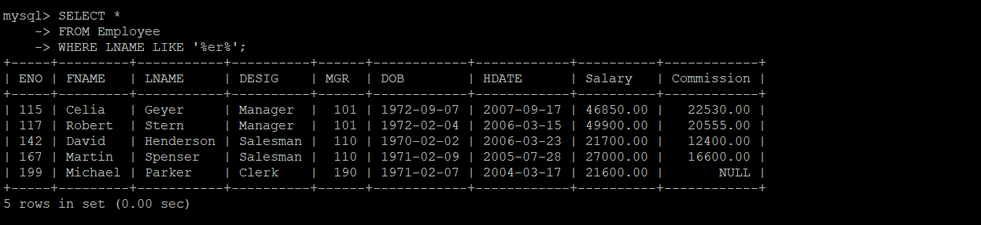

4)SELECT FNAME, LNAME

FROM Employee

WHERE FNAME REGEXP '^[MJ]\w*';

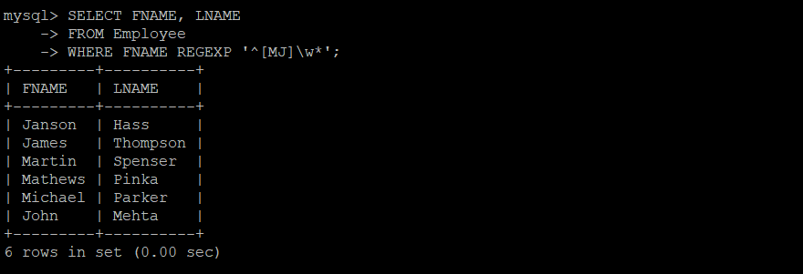

5)SELECT FNAME, LNAME, Salary

FROM Employee

WHERE DESIG LIKE '%Manager%';

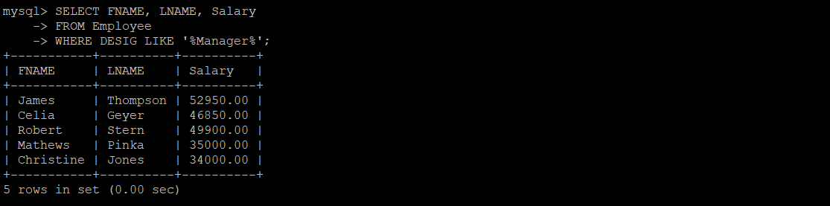

6)SELECT *

FROM Employee

WHERE DOB IN (SELECT MIN(DOB) FROM Employee);

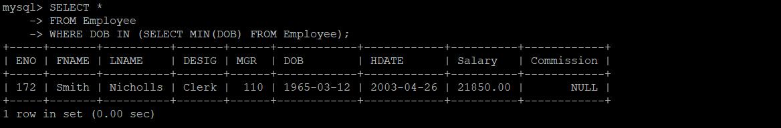

7)SELECT *

FROM Employee

WHERE DESIG NOT IN ('Manager', 'Analyst Manager');

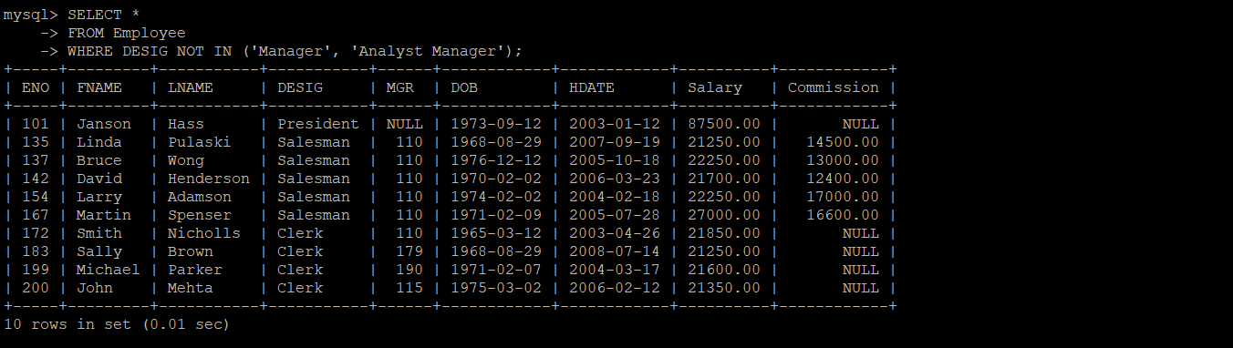

8)SELECT *

FROM Employee

WHERE Salary > 35000

AND (YEAR(DOB) BETWEEN 1966 AND 1976);

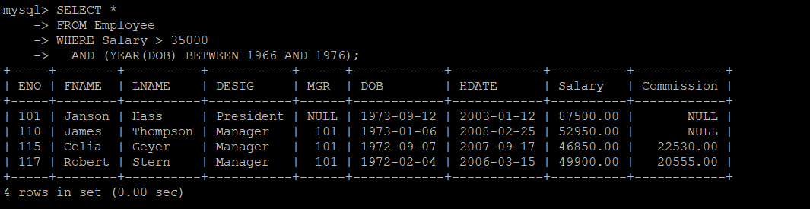

9)SELECT FNAME, LNAME, DESIG, Salary

FROM Employee

WHERE Salary >= 35000

AND DESIG IN ('Manager', 'Analyst Manager');

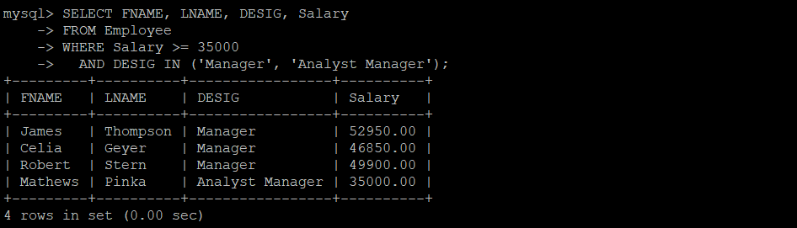

10)SELECT ENO, FNAME, LNAME, DESIG, Salary

FROM Employee

WHERE Commission >= 15000

AND DESIG IN ('Manager', 'Salesman');

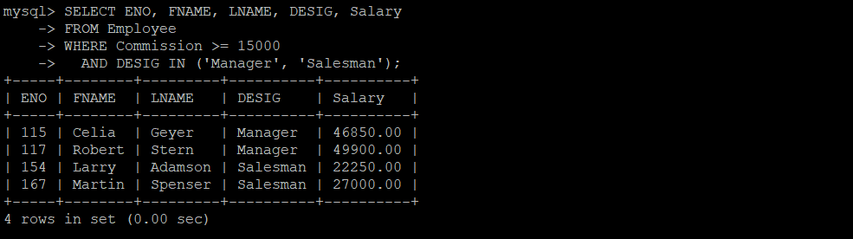

11)SELECT DESIG, COUNT(DESIG)

FROM Employee

GROUP BY DESIG;

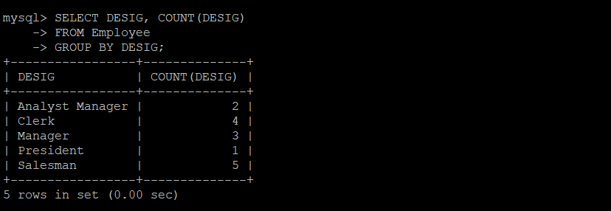

12)SELECT ENO, LNAME, Salary

FROM Employee

WHERE LNAME IN ('Thompson', 'Spenser', 'Geyer', 'Brown', 'Jones');

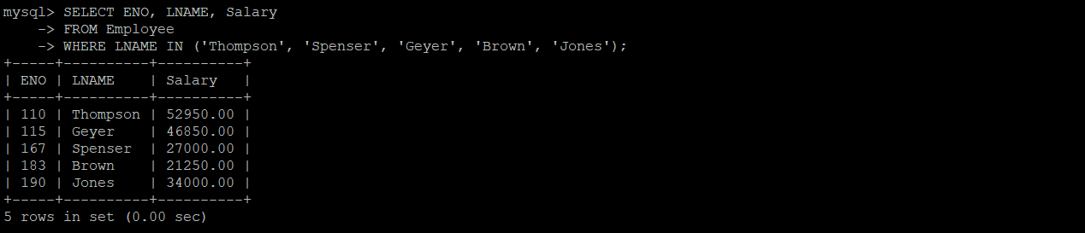

13)SELECT YEAR(HDATE), COUNT(*)

FROM Employee

GROUP BY YEAR(HDATE)

ORDER BY YEAR(HDATE);

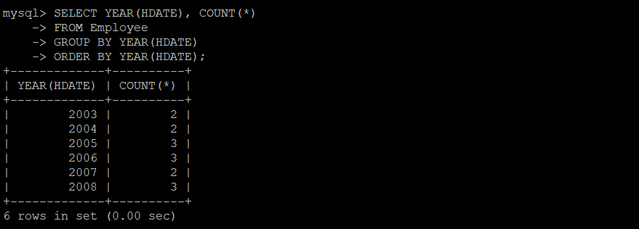

14)SELECT ENO, LNAME, Salary, TIMESTAMPDIFF(YEAR, DOB, CURRENT_TIMESTAMP)

FROM Employee

WHERE TIMESTAMPDIFF(YEAR, DOB, CURRENT_TIMESTAMP) BETWEEN 30 AND 40;



15)SELECT FNAME

FROM Employee

WHERE MGR IN (SELECT ENO FROM Employee WHERE FNAME IN ('James', 'Robert', 'Celia'));

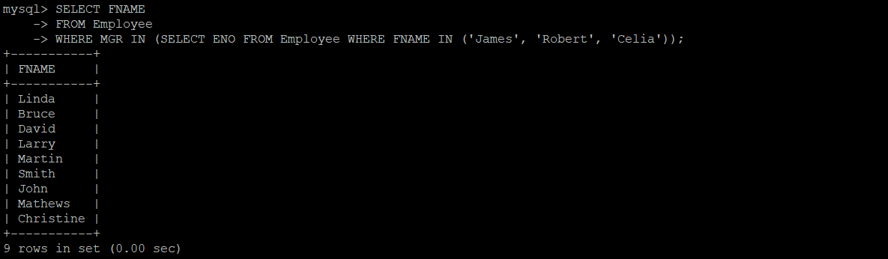

16)SELECT CONCAT('"', FNAME, '","', LNAME, '","', DESIG, '"')

FROM Employee;

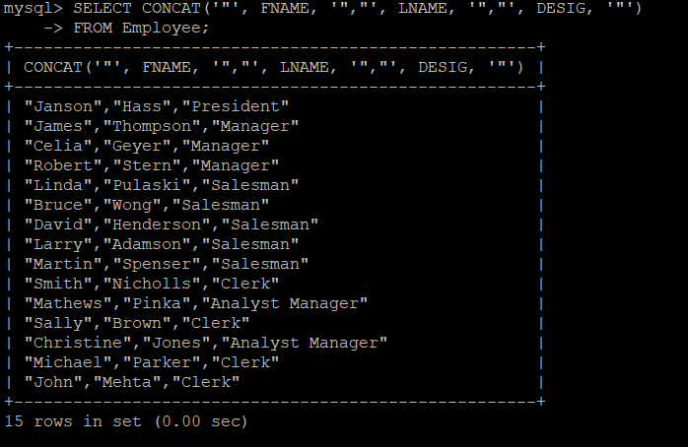

17)SELECT *

FROM Employee

WHERE Commission IS NOT NULL

ORDER BY DOB DESC

LIMIT 1;

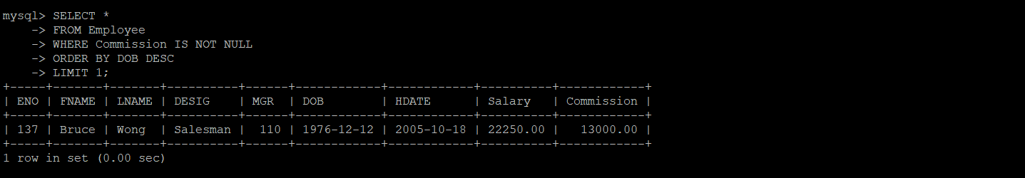

18)SELECT CONCAT('Dear \'', FNAME, '\', you were born on ', DATE_FORMAT(DOB, '%d, %D - %M - %Y'))

FROM Employee;

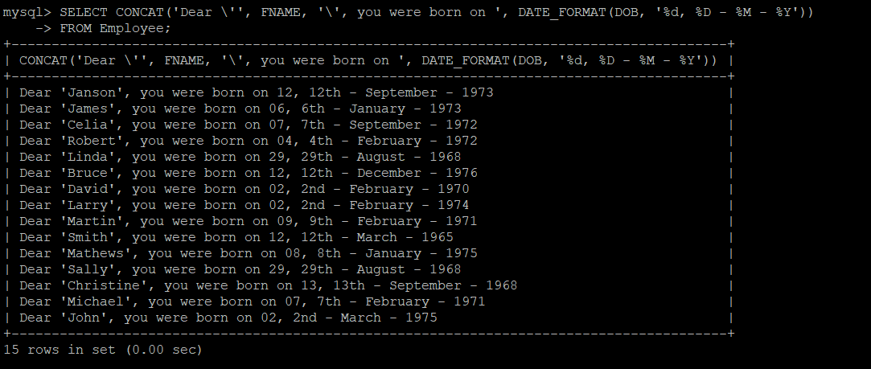

19)SELECT *

FROM Employee

WHERE (DESIG, Salary) IN (SELECT DESIG, MAX(Salary) FROM Employee GROUP BY DESIG);

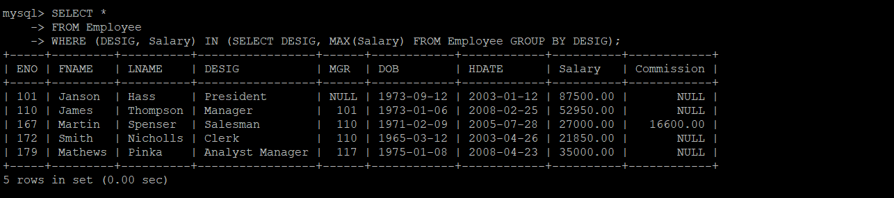

20)SELECT *

FROM Employee

WHERE MONTH(DOB) IN (1, 2, 8);

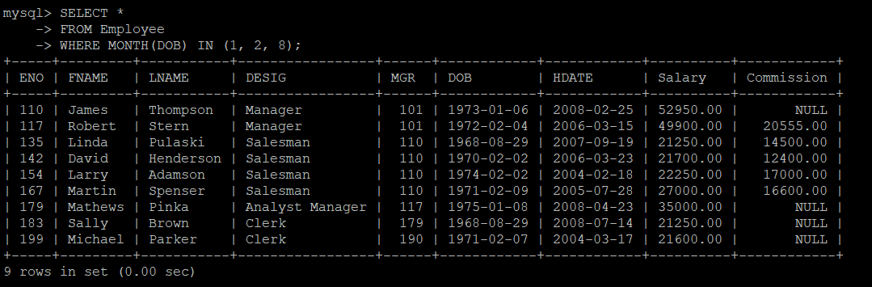

21)

SELECT CONCAT(FNAME, ' ', LNAME) AS Name,

Salary,

Commission,

Salary + COALESCE(Commission, 0) AS 'Total Remuneration'

FROM Employee;

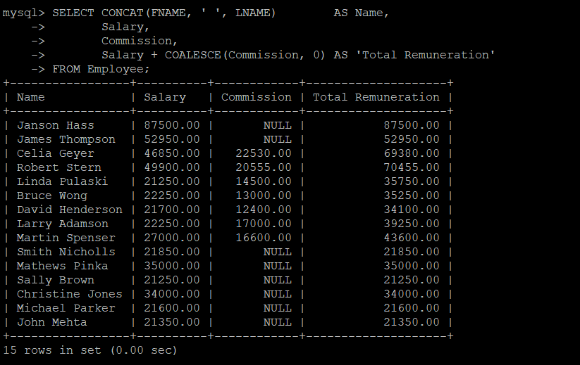

22)SELECT CONCAT(FNAME, ' ', LNAME) AS Name,

Salary,

COALESCE(Commission, NOT ISNULL(Commission)),

Salary + COALESCE(Commission, 0) AS 'Total Remuneration'

FROM Employee;

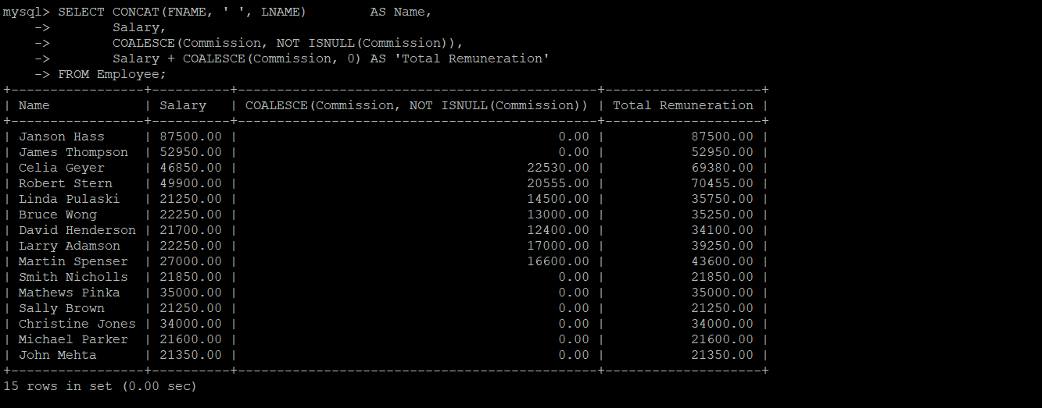

23)SELECT FNAME

FROM Employee

WHERE (DESIG, HDATE) IN (SELECT DESIG, MIN(HDATE) FROM Employee GROUP BY DESIG);

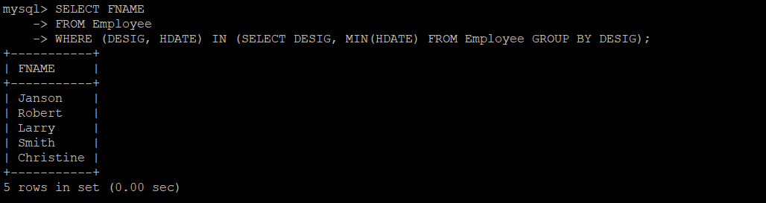

24)SELECT *

FROM Employee

WHERE DESIG = 'Manager'

AND YEAR(DOB) < 1973

AND Salary > 40000;

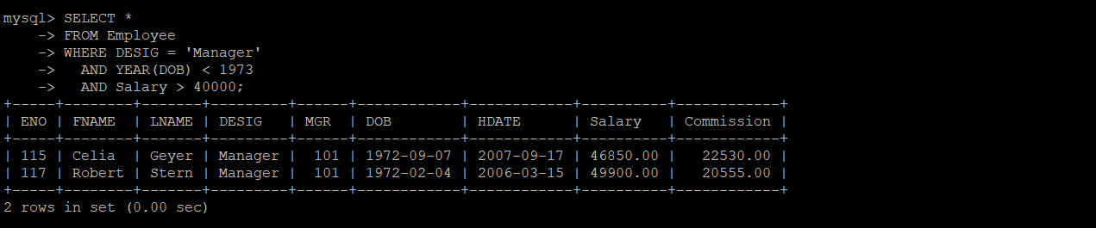

25)SELECT *

FROM Employee

WHERE Commission IS NULL

AND Salary BETWEEN 25000 AND 35000;

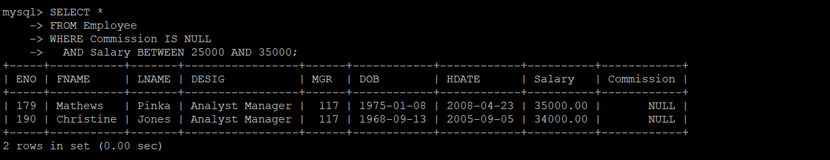

26)SELECT *

FROM Employee

WHERE MONTH(DOB) = MONTH(HDATE);

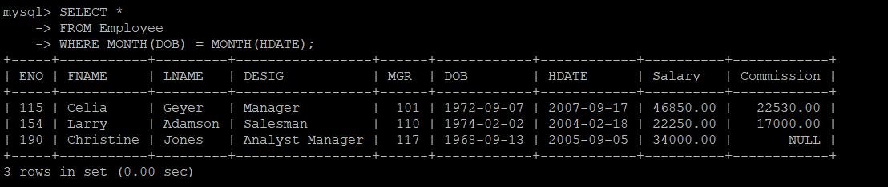

27)SELECT ENO, FNAME, DATE_FORMAT(HDATE, '%M %d,%Y')

FROM Employee;

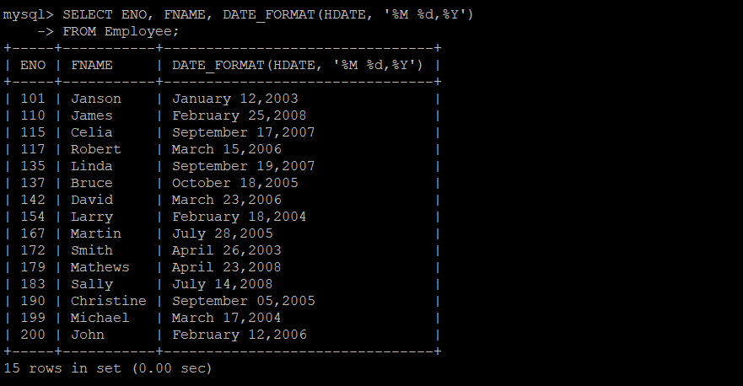

28)SELECT ENO,

CONCAT(FNAME, ' ', LNAME) AS Name,

DESIG,

HDATE,

TIMESTAMPDIFF(YEAR, HDATE, CURRENT_TIMESTAMP) AS Experience

FROM Employee

WHERE ENO IN (SELECT DISTINCT MGR FROM Employee WHERE MGR IS NOT NULL);

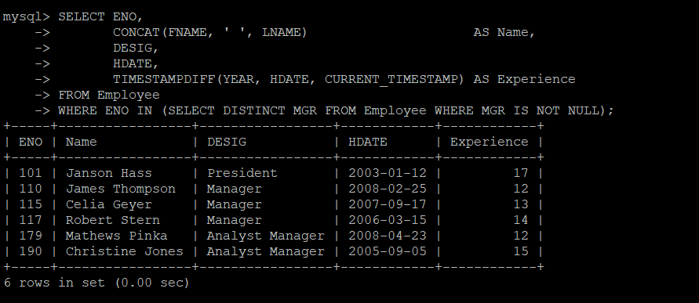

29)SELECT ENO,

CONCAT(FNAME, ' ', LNAME) AS Name,

Salary

FROM Employee

WHERE TIMESTAMPDIFF(YEAR, HDATE, CURRENT_TIMESTAMP) > 5

AND DESIG IN ('Manager', 'Analyst Manager')

AND Commission IS NULL

ORDER BY ENO;

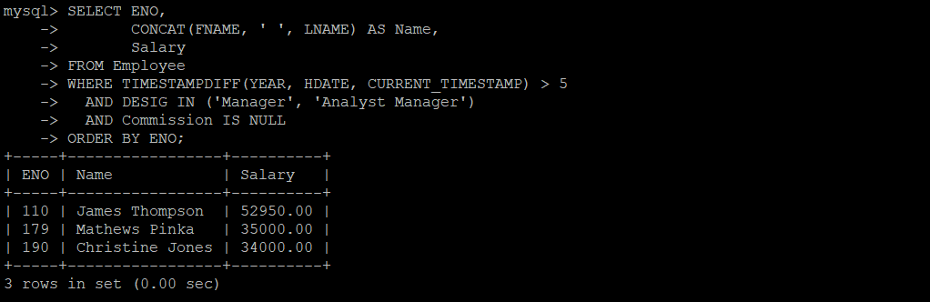

30)SELECT *

FROM Employee

WHERE HDATE > (SELECT HDATE FROM Employee WHERE FNAME = 'Martin');

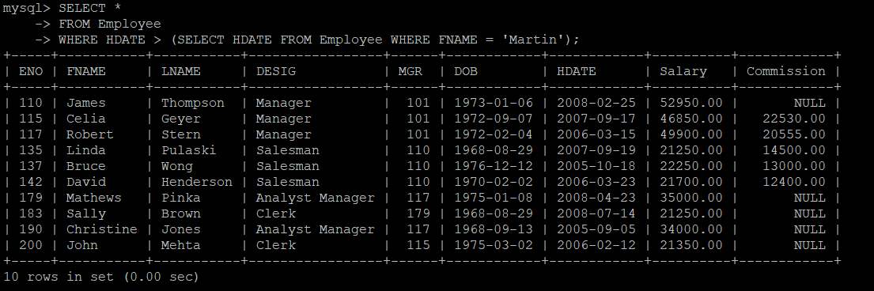

31)SELECT FNAME

FROM Employee

WHERE Salary IN (SELECT Salary FROM Employee WHERE FNAME = 'Larry');

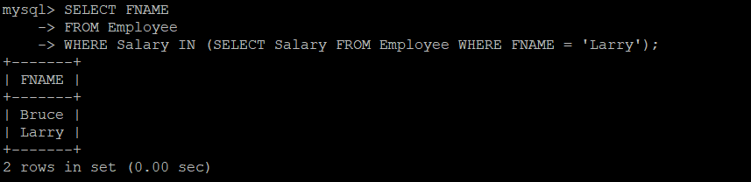

32)SELECT FNAME

FROM Employee

WHERE DESIG IN (SELECT DESIG FROM Employee WHERE FNAME = 'James') # Should james be included are not?

AND Salary > (SELECT Salary FROM Employee WHERE FNAME = 'Celia');

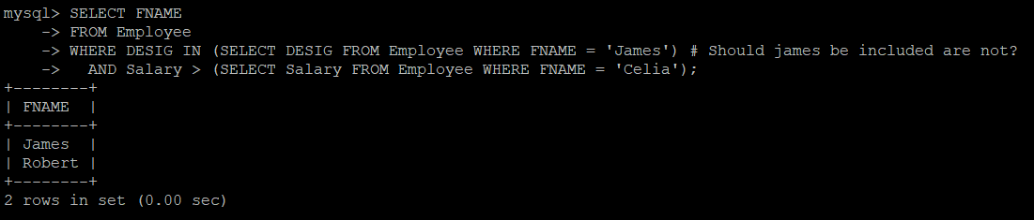

33)SELECT *

FROM Employee

WHERE (Salary + COALESCE(Commission, 0)) =

(SELECT MAX(Salary + COALESCE(Commission, 0)) FROM Employee);

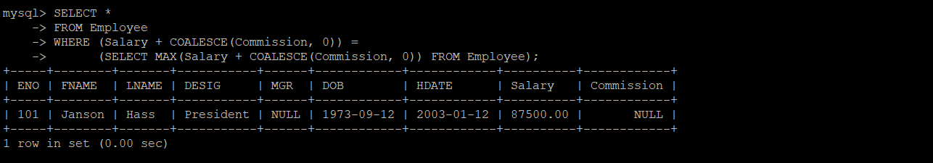

34)SELECT *

FROM Employee

WHERE DESIG = 'Salesman'

AND HDATE = (SELECT MAX(HDATE) FROM Employee WHERE DESIG = 'Salesman');

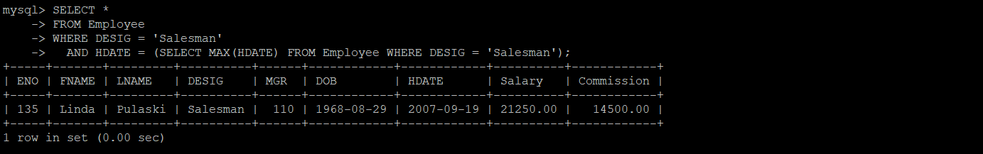

35)SELECT *

FROM Employee

WHERE MGR = 110

AND HDATE < (SELECT MAX(HDATE) FROM Employee WHERE MGR = 110);

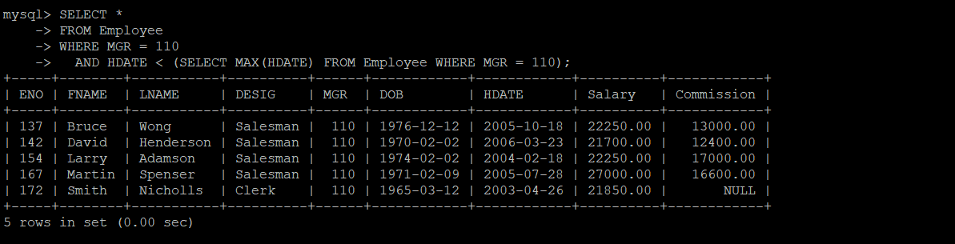

36)SELECT *

FROM Employee

WHERE HDATE < (SELECT MAX(HDATE) FROM Employee WHERE YEAR(HDATE) >= 1991);

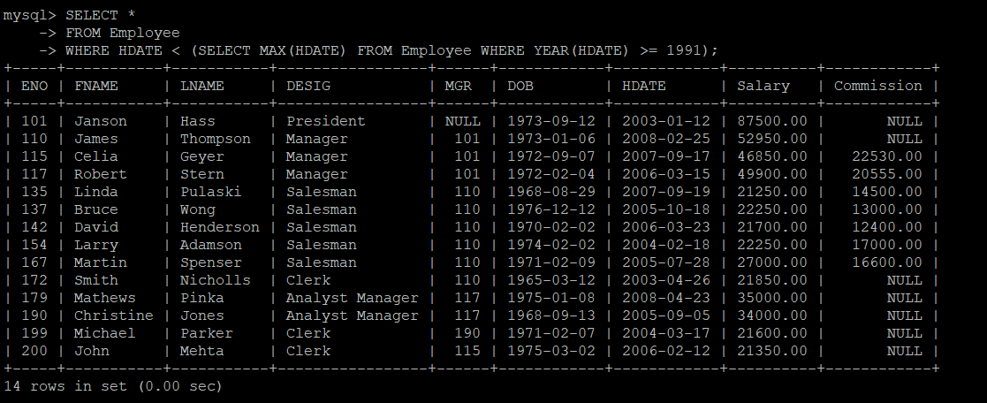

37)SELECT CONCAT(FNAME, ' ', LNAME) AS Name

FROM Employee

WHERE Salary >= (SELECT (MIN(Salary) + MAX(Salary)) / 2 FROM Employee);



38)SELECT CONCAT(FNAME, ' ', LNAME) AS Name

FROM Employee

ORDER BY (Salary + COALESCE(Commission, 0))

LIMIT 5;

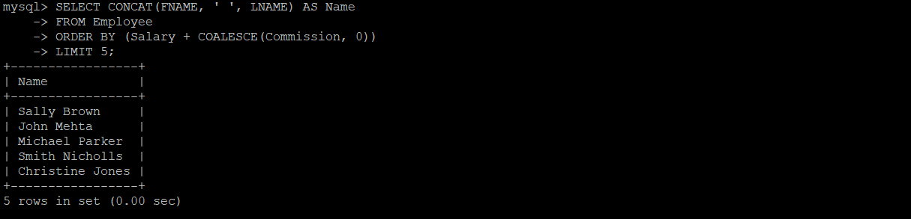

39)SELECT CONCAT(FNAME, ' ', LNAME) AS Name,

Salary,

COALESCE(Commission, NOT ISNULL(Commission)) AS 'Commission',

Salary + COALESCE(Commission, 0) AS 'Netpay'

FROM Employee

WHERE (Salary + COALESCE(Commission, 0)) = (SELECT MAX(Salary + COALESCE(Commission, 0)) FROM Employee);

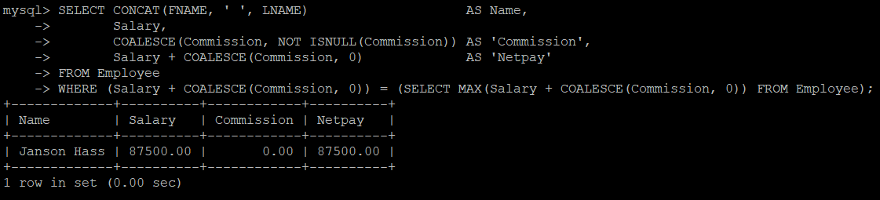

40)SELECT CONCAT(FNAME, ' ', LNAME) AS Name

FROM Employee

WHERE HDATE IN (SELECT HDATE FROM Employee GROUP BY HDATE HAVING COUNT(*) > 1);

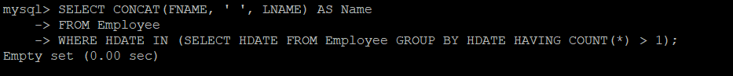

41)SELECT COUNT(*)

FROM Employee

WHERE MGR IS NULL;

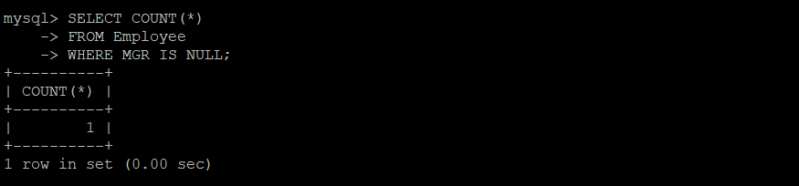

42)SELECT CONCAT(FNAME, ' ', LNAME) AS Name

FROM Employee

WHERE ENO IN (SELECT MGR

FROM Employee

GROUP BY MGR

HAVING COUNT(*) = (SELECT COUNT(*) FROM Employee GROUP BY MGR ORDER BY COUNT(*) DESC LIMIT 1));

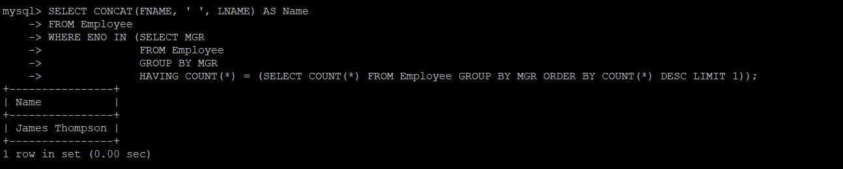

43)SELECT *

FROM Employee

WHERE (DESIG, HDATE) IN (SELECT DESIG, MAX(HDATE) FROM Employee GROUP BY DESIG)

ORDER BY HDATE;

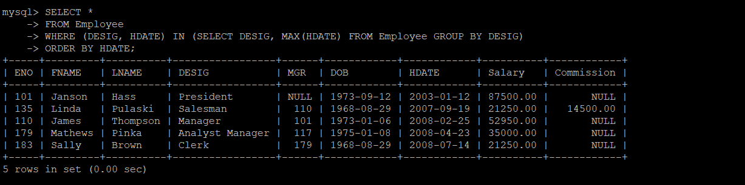

44)SELECT CONCAT(FNAME, ' ', LNAME) AS Name, DESIG

FROM Employee

WHERE Commission IS NOT NULL

AND Salary IN (SELECT MAX(Salary) FROM Employee WHERE Commission IS NOT NULL);

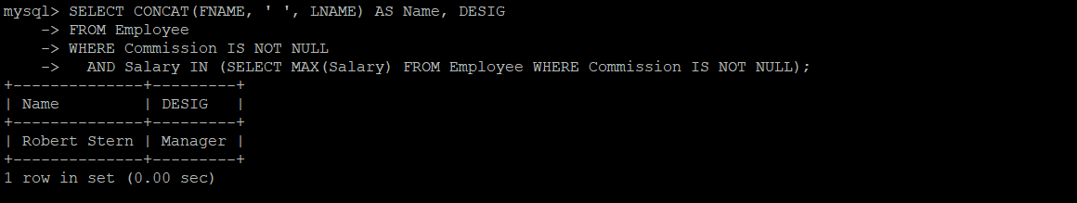

45)SELECT *

FROM Employee

WHERE Salary IN (SELECT Salary FROM Employee GROUP BY Salary HAVING COUNT(*) > 1);

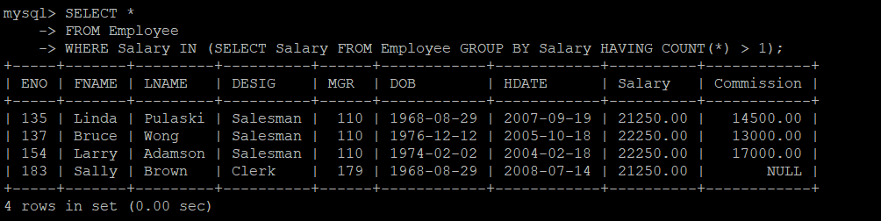

46)SELECT DESIG, AVG(Salary)

FROM Employee

WHERE DESIG != 'President'

GROUP BY DESIG

ORDER BY AVG(Salary) DESC

LIMIT 1;

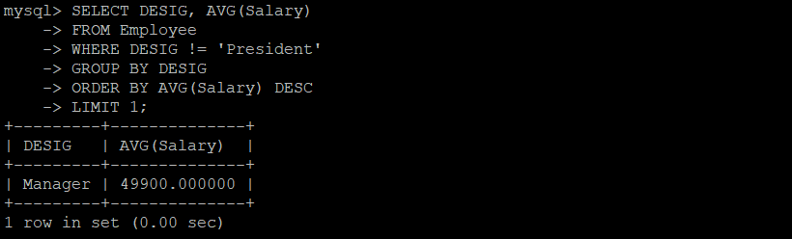

47)SELECT ENO

FROM Employee

WHERE ENO NOT IN (SELECT DISTINCT MGR FROM Employee WHERE MGR IS NOT NULL);

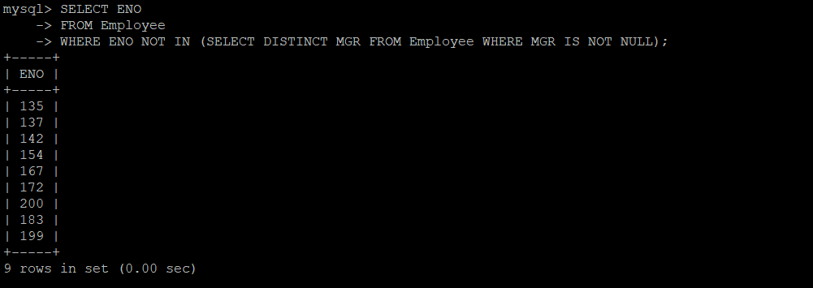

48)SELECT SUM(Salary + COALESCE(Commission, 0)) AS 'Total Remuneration'

FROM Employee

WHERE MGR = 110;

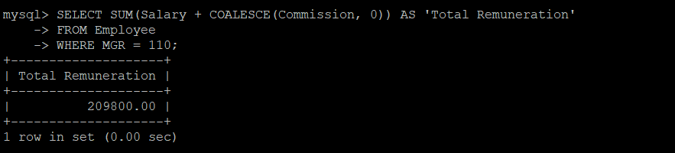

49)UPDATE Employee

SET Commission = Commission + (Salary * 0.1)

WHERE MONTH(DOB) = MONTH(CURRENT_DATE);

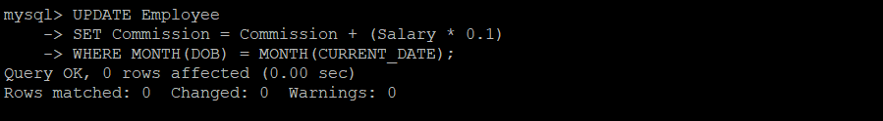

50)DELETE

FROM Employee

WHERE Salary > 40000

AND DESIG NOT IN ('President', 'Manager');

